Debian dhcp server

Version 9.4

#install

apt-get install isc-dhcp-server

#先設定要發DHCP的網卡

vim /etc/default/isc-dhcp-server

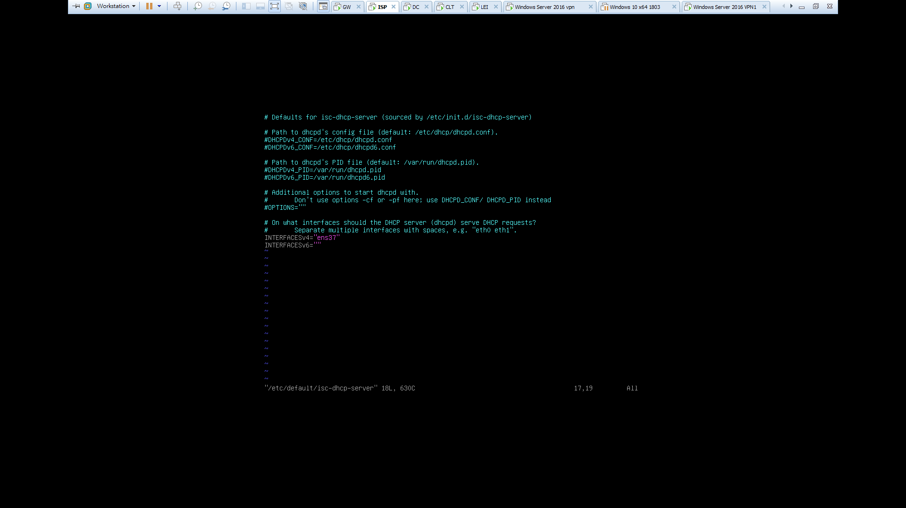

Vim /etc/dhcp/dhcpd.conf

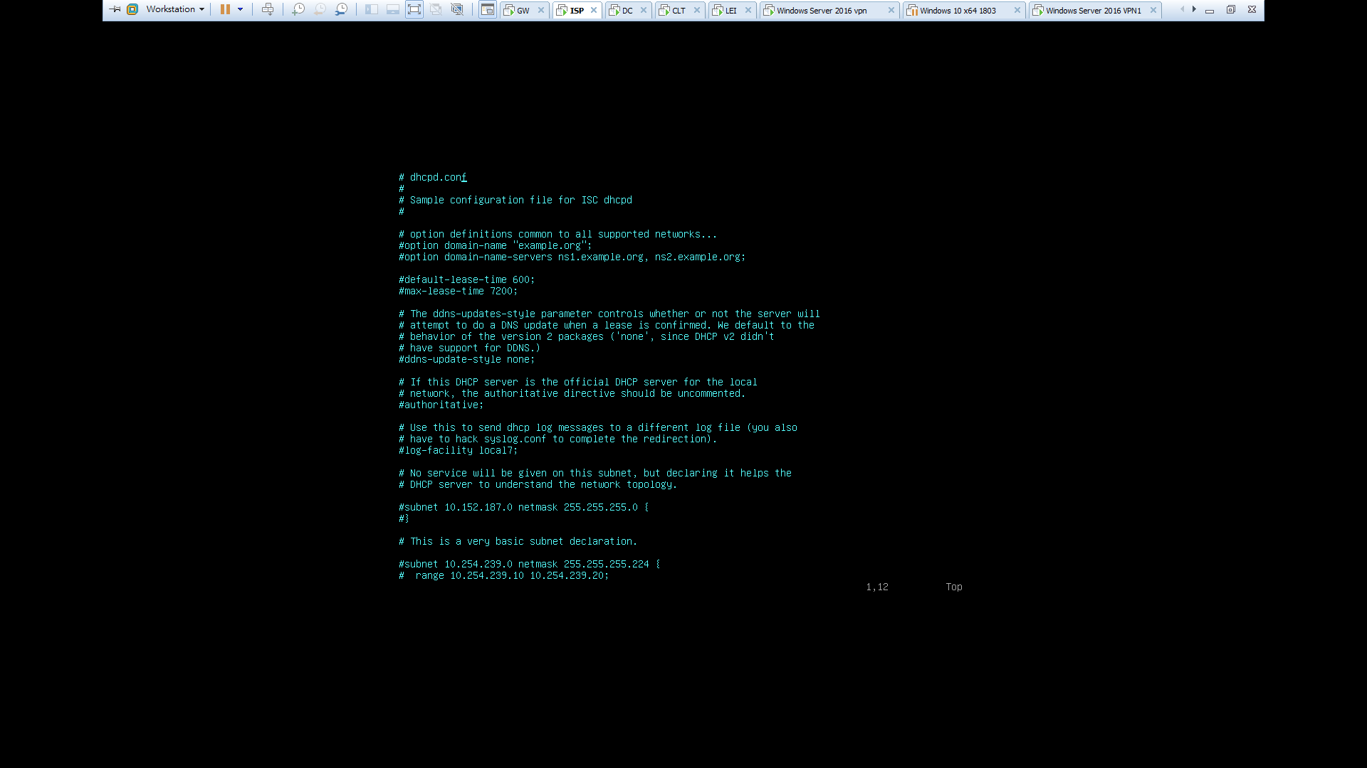

#註解掉 option domain-name & option domain-name-servers

&default-lease-time & max-lease-time

#往下大約50行處把subnet{}的註解拿掉

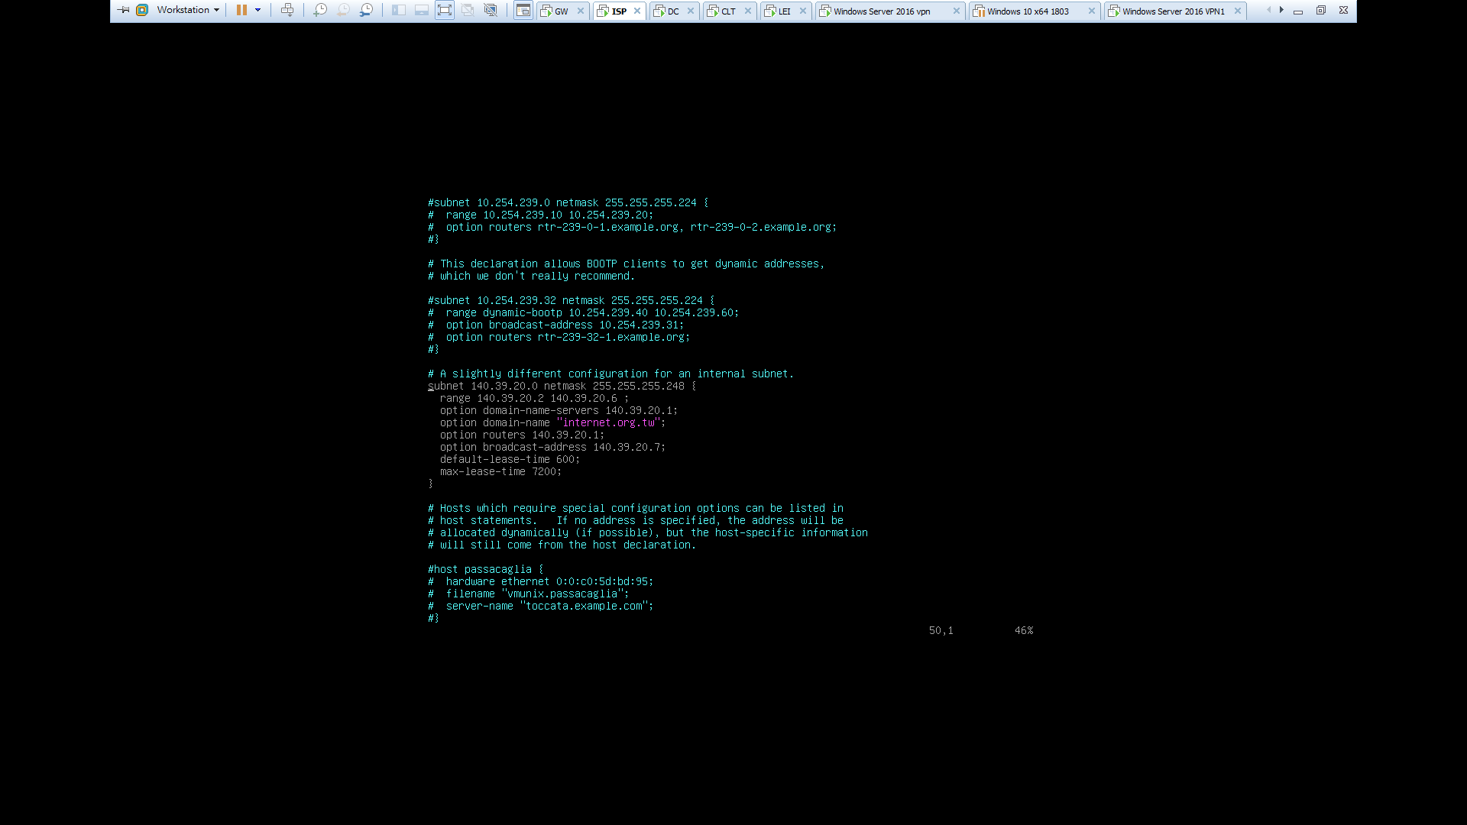

#設定DHCP各項參數

dhcp log

vim /etc/rsyslog.conf

local6.* -var/log/dhcpd.log

# 新增 local6.none 設定local6的記錄不寫入messages  
*.info;mail.none;authpriv.none;cron.none;local6.none

vim /etc/dhcp/dhcpd.conf

log-facility local6;

touch /var/log/dhcpd.log